Blade Server

🗡️ What is a Blade Server?
# Source: AI Source: Provided by: [Data Path: Persons Table -> ID Column: 1, Name_En Column: Motasem Essam] -> From: [ChatGPT] on [1/16/2026]
A Blade Server is an ultra-thin, modular server that fits into a larger blade chassis, which provides shared power, cooling, networking, and management.
📌 Think of it like a server card that slides into a special case — similar to how you insert a book into a bookshelf.

Blade Server images
# Source: ScreenShots Source: Provided by: [Persons Table -> ID Column: 1, Name_En Column: Motasem Essam] -> Tool: [Lightshot Program] -> From [Site: Google Search: Images: Blade Server] on [1/16/2026]
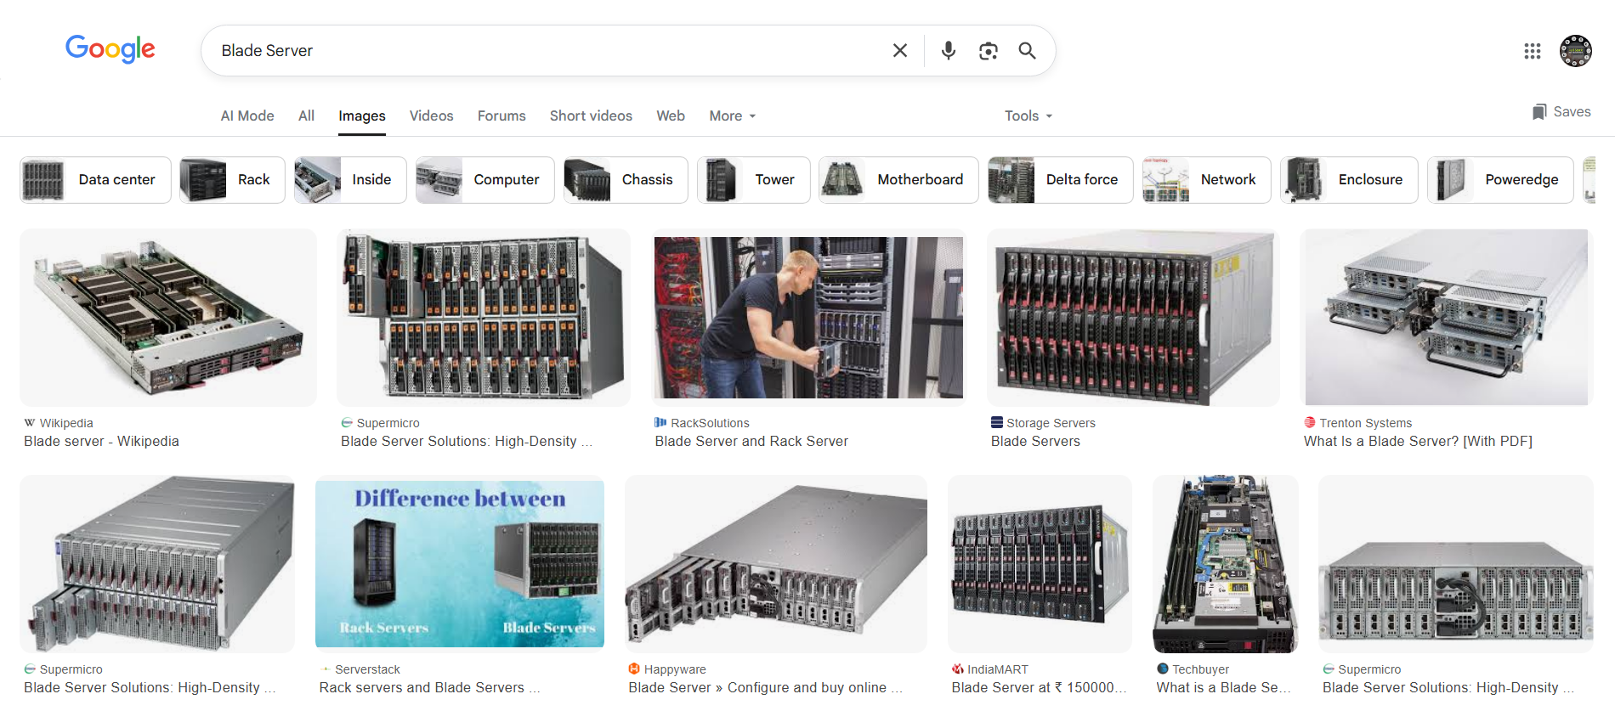

🧠 Key Characteristics
# Source: AI Source: Provided by: [Data Path: Persons Table -> ID Column: 1, Name_En Column: Motasem Essam] -> From: [ChatGPT] on [1/16/2026]
Feature | Description
📏 Form Factor | Very slim (often 1–2 inches thick), no case — fits into a blade enclosure
🧰 Modular | Each "blade" is a complete server (CPU, RAM, storage)
♻️ Shared Chassis | Multiple blades share power, cooling, and networking from the enclosure
📡 High Density | Up to 16+ servers in a small rack space
🖥️ Managed Centrally | Blade enclosure includes built-in management system (e.g., iLO, IPMI)

🧪 Example Setup
# Source: AI Source: Provided by: [Data Path: Persons Table -> ID Column: 1, Name_En Column: Motasem Essam] -> From: [ChatGPT] on [1/16/2026]
[ Blade Enclosure (Chassis) ]
├─ Blade 1: Web Server
├─ Blade 2: Database Server
├─ Blade 3: Virtualization Host
├─ Blade 4: Backup Server

Each blade is hot-swappable and works as an independent server.

✅ Advantages of Blade Servers
# Source: AI Source: Provided by: [Data Path: Persons Table -> ID Column: 1, Name_En Column: Motasem Essam] -> From: [ChatGPT] on [1/16/2026]
Benefit | Why It Matters
📦 Space-efficient | Pack dozens of servers in one rack
⚙️ Easy to scale | Slide in more blades as needed
🔌 Shared power/network | Reduces cables, saves energy
🧠 Central management | Unified control panel for all blades
🛠️ Hot-swappable | Replace/upgrade without downtime

❗ Considerations
# Source: AI Source: Provided by: [Data Path: Persons Table -> ID Column: 1, Name_En Column: Motasem Essam] -> From: [ChatGPT] on [1/16/2026]
Limitation | Description
💰 Cost | Higher upfront investment (chassis + blades)
❄️ Cooling required | Generates a lot of heat — needs proper airflow
🔧 Complex setup | Not ideal for beginners or home use
⚡ Power usage | High density = high power draw

🔍 Blade vs Rack vs Tower
# Source: AI Source: Provided by: [Data Path: Persons Table -> ID Column: 1, Name_En Column: Motasem Essam] -> From: [ChatGPT] on [1/16/2026]
Feature | Blade | Rack | Tower
Size | Ultra-slim modules | Flat servers (1U, 2U, etc.) | PC-like upright cases
Installation | Needs blade chassis | Mounted in 19" rack | Freestanding
Best for | Enterprise, cloud/data center | Mid-size businesses/data centers | Small businesses, home labs
Cost | 💲💲💲 | 💲💲 | 💲
Scalability | 🌟🌟🌟 | 🌟🌟 | 🌟

🧰 Examples of Blade Server Models
# Source: AI Source: Provided by: [Data Path: Persons Table -> ID Column: 1, Name_En Column: Motasem Essam] -> From: [ChatGPT] on [1/16/2026]
Model | Manufacturer | Notes
HPE BladeSystem c7000 | HP Enterprise | Popular in enterprise setups
Dell PowerEdge M1000e | Dell | Supports 16 blades per chassis
Cisco UCS B-Series | Cisco | Integrated with networking gear
Lenovo Flex System | Lenovo | Modular compute + storage

✅ Summary
# Source: AI Source: Provided by: [Data Path: Persons Table -> ID Column: 1, Name_En Column: Motasem Essam] -> From: [ChatGPT] on [1/16/2026]
Property | Value
What is it? | A server module that fits in a shared enclosure
Used by | Data centers, enterprise cloud platforms
Key Advantage | High density + shared power/cooling/management
Best For | Large-scale, centralized IT environments

